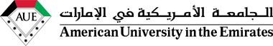

The Impact of Social Media on Revolutions

IRE 405 - Capstone Graduation Project
Spring 2019/2018
Dr. …………………………………………..
Emirate of Dubai, United Arab Emirate

By:
Name:
ID:

Contents:

Abstract 3
Chapter 1 4
1.1 Introduction 4
1.2 Background 6
1.3 Statement of the problem 8
1.4 The purpose of this study: 9
1.5 Theoretical bases and Organization: 10
1.6 Limitations of the study: 11
Chapter 2 12
Literature view 12
Chapter 3 13
3.1 Methodology: 13
3.2 Design of the Research: 13
3.3 Data and Analysis Procedures 14
Chapter 4 17
4.1 Presentation of findings 17
4.2 Discussion of the findings: 20
4.3 Recommendations: 21
4.4 Summary and Conclusions 22
Reference: 23

Abstract
The evolution of communication technologies has changed the lives of individuals in terms of their relationships with people, and it effects the countries and their international relations .My research will highlight the effect of social media on the practice of international relation, the main purpose of my research is to show how social networking play a big role in our life. Nowadays, there are many countries’ that are media center they use social networking as a weapon to increase its relations worldwide. I will discuss some of those countries and how they rely on social media to build strong relationship between other countries.
The fast growth of the media and communication has led to a real revolution and essential changes in all spheres of the life. The impact of these many changes has taken place at the level of individuals and group not only to a limited level but also further than the global level. It led to phenomena and it has a direct influence and effects on different political structures and social.
In our community many peoples use social networking to build strong relationship among others and enhance the power of international relation. In my research paper I will conduct a questionnaire to get some feedback form American university in the Emirates students about my point of view, by the end of my report you will get to know the importance and the influence of social networking in building a strong international relations.

Chapter 1

1.1 Introduction

The prevalence of social networking platforms such as Twitter, Facebook, Instagram, YouTube. Spread enormously and significantly among the peoples all over the world especially among the Arab countries in particular. This platform has a significant impact on the society, which leads the governments to loss their control over the media. It becomes the true voice of peoples.
This has add to what has turned out to be known as the social media that have turned into the methods for correspondence influencing the day by day occasions in order to give the chance to all political youth, and researchers to expresses their thoughts and examine their social and political issues and what they want to beyond regular fringes to new spaces unchecked. Indeed, yet governments and NGOs are utilizing these systems to impart their thoughts and accomplish their various objectives.
Thus, it is likely to say that the social media has caused a subjective jump not just in the field of correspondence among groups and individuals, as this correspondence has had important outcomes in the social, political, humanitarian and cultural. To the extent that has become one of the most important factors of social change locally and globally, this means that the traditional media are no longer capable of making this change, but are unable to directly and effectively influence social networks. And what happened in the Arab region the Arab Spring. It’s a proof of the strength of social networks and how it played an important role in late 2010 and early 2011.
Social networking sites that allow users to communicate through virtual reality to meet other peoples It is similar to the natural reality by forming relationships with friends of different ages and races and from all over the world. They share common interests and activities despite their different minds, thinking and culture participants exchange experiences, knowledge, and information.
People’s talks through the media to convey a constrained message of purpose to people in general, the media that screens government activities and strategies for practicing power, there are also members of the society who take part in the political procedure through the media to express their perspectives on their issues and the progression of information from the media to opinion influential in society is the best means of worldwide relations, they transmit data published by the media in a technique that analyze and discloses to the society and presents their various perspective of such data and media communication
Government's ownership and control over the media is clearly disappearing. In a world in which the media can cross the border quickly and effectively via the Internet and satellite radio and television services, governments can no longer control the spread of the media and reach their citizens that people no longer accept government-controlled media and limit their role to providing them with one-sided, limited and biased views. From the core of the globalization of technologies emerged the globalization of the media and this means that the news has become the ability to penetrate the barriers and access to any place and cant be prevented from spreading, whatever attempts. The government media have no choice but to develop them selves and use new methods to awareness the public.
In today’s information age, the advancement in technology, particularly the Internet has revolutionized the way we communicate. Whether we realize it or not, this phenomenon has made a deep impact on virtually every aspect of the modern human life. By the passage of time, it has been observed that the value of social media had tremendously increased, causing people who have political interest to enact social networking as tactics and means of communication furthermore, sharing data. As a result of such a fast development of this new type of innovation, it is basic to quantify what number of individuals utilizes web-based life? What do they use it for? How frequently do they use it?
Social media platforms, for example, Facebook have turned out to be known as the new online networking, which is considering a dynamic development of improvement and spread. It was at first a virtual society on a tight and constrained scale, and after that step by step developed from a composed printed device a various media device that impacts the choices of those responds and affected.
Social networking sites are one of the most recent and most common correspondence technology items. Despite the fact that these sites were made basically for social correspondence between people, their utilization was stretched out to include political action through the circulation of data in different fields. Today, social media sites have turned out to be significant foundations Which assume a significant role in giving the behaviors and habits, regardless of whether right or wrong and a significant tool of social awareness, political and social and in addition it play a successful role in affecting the mind of the users.
On a negative note, with the new technology of social media it has become simpler to gain trust of audiences and encourage employer on its right value and its commitment Therefore, social networking in comparison with traditional media such as Radio, Magazine Ads, Television, and Newspapers. Are considered effective and successful. Furthermore, social media networks are low cost and are a fewer effective means of communication, redistribution of news than traditional media, and it quickly influences the international ’s perception on certain issues. Despite the wide spread of means of social communication and the Internet, but there are a group of people, especially the elderly, they still relying on the traditional media to get information such as television, newspapers and radio. Traditional media it has one-way communication, the audience cannot interact and share their own feedback with public. However, social media has both direction user can receive information and share his/her feedback by adding and commenting on the same topic at the time.

1.2 Background

Social networks such as Facebook, Twitter, YouTube emerged in 2011 in the Arab Spring as an effective channel for political change. As well as the various protest movements in the world.
In the return to the main events of the "Arab Spring" and the beginning of Tunisia, the role played by social networking sites in the Tunisian popular uprising can be summarized as saying that part of the history of the "youth revolution" in Tunisia was written on the virtual wall of Facebook,
Zine El Abidine Ben Ali's regime has been wielding its grip on electronic communications, restricting journalists and media and preventing local and foreign correspondents from traveling to Sidi Bouzid to cover events. The official media described the events as acts of terrorism and sabotage, and the authorities tried to withhold information and change it.
With the repression and media restrictions that the Tunisians were living in, the alternative was the Internet, specifically Facebook, where Tunisians managed to circumvent censorship and media blackout, and allowed many to transfer a great deal of information from pictures and videos to the world and Tunisians Through Facebook and the Internet, which helped convince the Tunisians that it was time for the uprising and move out to the street and join the young in their revolution.
In Tunisia as well as in Egypt, social networking sites, specifically Twitter, have been active in calling for demonstrations and for coordinating the protest. The Internet has changed people's perceptions through awareness campaigns by Egyptian activists to promote human rights and political "citizen" rights. In Egypt, social networking sites play the largest role in organizing activists, in transmitting the pulse of the street, and in transmitting the facts of the events, in the heart of the demonstrations, exchanging information about the places of gatherings, in addition to various advice to confront arrests, how to avoid teargas and other things to protect demonstrators.
In Libya at the outbreak of the February 17 revolution, blogger Mohamed Nabous founded Libya Free Channel, the first independent private television station established in the territory controlled by the National Transitional Council (NTC). Where the international media reported the first images conveyed by Nabos about the destruction and battles in the city of Benghazi. Muhammad Nabous was killed on 19 March 2011 by snipers when he tried to take pictures of the destruction of the city of Benghazi by the bombing of the Gaddafi Brigades in the second battle of Benghazi.
In Syria, with the rising pulse of protests against the regime of Bashar al-Assad in Syria, escalated confrontations in the electronic space, where the Web turned into a real battlefield, a group emerged on the site "Facebook" called itself "The electronic Syrian Army " The group has launched a new approach to dealing with protests and opposition by pirating the personal pages of some opponents of the Syrian regime, as well as penetrating Arab, Western media sites and Israeli websites. With the Syrian regime blocking the work of international media journalists on the Syrian territories, the media resorted to what is being circulated on the social networking sites "YouTube" and "Facebook" and "Twitter", which publishes videos of demonstrations or battles depicted in the cell phone, Without verifying the authenticity of what is stated in those files.
The main project hypnosis that social media has big impact on international relation his does not suggest that there are no incomplete or restricted theories that can be connected to specific parts of that research for instance, there are a scope of helpful hypotheses in the zones of improvement.
The Arab world is currently experiencing a unique crisis with many political, social and economic challenges. All the societies of the region, poor and rich, in Arab country, when we come to media and its practices, we found that social media has a big impact on the Arab countries, and it caused many issues.

1.3 Statement of the problem

The popularity of social media has grown in the first quarter of 2011,
The Facebook and Twitter user platforms, for example, expanded significantly, exceeding the number of Facebook users 677 million in April of the year.
The first three months of 2011 witnessed a major shift in the use of social media by the Arab world and aimed at mobilizing the public through the Internet, whether by citizens to organize demonstrations whether pro-government or anti-government or in some cases the governments communicate with citizens and encourage them to Participate in government procedures, or some other cases, to block websites or monitor information’s published by others.
In many Arab countries, there were many Internet disconnections during the first quarter of 2011, which lasted five days in Egypt, from 28 January to 2 February. In Libya, there has been a decline in Internet access and a reduction in the use of Internet time. In contrast to the case of Syria, where the government lifted the ban on social media sites in 2011, the use of YouTube and other social media sites increased sharply.
The number of Facebook users has increased significantly in most Arab countries, and has increased significantly in countries where the protests began. The role of social media in the revolutions that swept the region has been highly controversial. Some views call it the main instigator of these revolutions, while others diminish their role and see it as mere tools. And yet, we can say that the calls for protests in the Arab region were launched mainly from Facebook.
This does not mean that there is a causal relationship or that the Facebook pages were the main or only factor behind the organization of the demonstrators themselves and their departure in those specific days, but as the platform from which these invitations were launched, no one can deny that it was a factor in mobilizing these movements. However, due to the weak spread of Facebook in most of these countries, for example in Syria and Yemen.
We can say that the role of these means was not essential to many of the protesters. We can also say that Facebook was a useful tool for a core of activists who later succeeded in mobilizing broader networks through other platforms or through traditional social networks.
The Arab Spring, Facebook revolution, the Pharaohs revolution, Jasmine revolution, revelation of Dignity, the Green revolution, have been occurred. Although the common revolutions that cleared through the Middle east and North Africa, Despite the qualification of these desire and labels of people to autonomy and freedom, the social media played a main role in these famous movements, and most of them were from younger generations, denied of the most essential social equality to opportunity and work and to express there opinions, this age of youth chose to face the governments The youngsters become journalist, reporters and writers, and most of the majority may not know anything before these occasions about what social media are and their job in spreading their challenge.
Whether researchers differed in determining the role of social networks in the Arab Spring revolutions and the strength of its influence or not, but it is certain that large sections of the Arab youth used these sites to express their opinion and contact with each other, where the opportunity was available to young people from all Arab countries to communicate more, These sites enabled the Arab youth to transfer the distress of the Arab communities to the international community and to force them to take positions against violence, violation of human rights and to satisfy their desires.

1.4 The purpose of this study:

• The growth of social networking in Arabic country.
• Some people use social media to make strong international relations
• Political countries rely on social media to build a strong relation and spread its awareness in negative and positive point.
Political belief system and the occasions encompassing these systems have turned into a type of discussion on open issues and have empowered political elites to beaten their truancy in the customary open circle constrained by the state.
Social media don't work in segregation from their unique situation (virtual society). On the off chance that the essential reason of a virtual society since its initiation depends on the sharing of interests, when groups or individuals get to social media, they depend on worries that are thus ideologically characterized, Intellectual decision for users
That social media delivered new types of aggregate activity and made elective spaces that called virtual group and conformed to them basic political, aesthetic, social, sports and expert concerns discharged from various ideologies.
The development of general assessment leaders has given them media stages and their very own procedures to activate the majority and prepare people. This might be a standout amongst the most significant ideological determinants of social media, since public opinion pioneers in correspondence sites impact society and become dynamic in changing social and political life. The political world, particularly the Arab reality, has risen as new actors from various nations of the world. They don't try in the succession of the arranged society, which has turned into an arrangement of political, social, and communicative relations to be a name for their character.

1.5 Theoretical bases and Organization:

This research is corresponding with other research that provided by the results, which were drawn but it differs from the rest of the research at the end of the study the important of social media to build strong international relation in different country around the world.
• Hypotheses:
Social media is strong weapon to build a strong relationship in international manner globally
• Hypotheses:
Social media have moved toward becoming piece of challenge developments against authoritarian regimes and break their control on data. They have additionally put pressure on authorities and governments by uniting groups of people on merged thoughts and perspectives.
This has prompted the wealth of societies and the consciousness of society individuals from their rights and obligations. The manner by which nations interact with social media sites contrasted as they turned into a pointer of the level of political change and majority rule government in those nations and started to consider the significance of adjusting these destinations as methods for opportunity and expression and the requirement for controls to be utilized To remain without turning into a means that threatens the security of society or the dependability of regimes, as occurred in certain nations.

1.6 Limitations of the study:

There are determinants related to the privacy of the information society, the network society and the motivation of certain armed groups and terrorist organizations to make the networks the address of their electronic identity. They also sought to establish private networks, for example, group of people had become outside the service one day after its launch, to be an address on the basis of the entity publishes through the propaganda and intellectual format, so it becomes the platform or means here not only the carrier of the letter or the media message of this group or that organization, but become the platform is the means The message itself, according to (Charles McLuhan), as well as the determinants of electronic warfare launched by individuals or groups or countries targeted social networking sites reveal the ideological nature of these wars and emphasizes on the other hand the conflict about the meanings and ideas and perceptions (ideological conflict) The networks are platforms for an ideological struggle for these sites. Networks thus constitute platforms for an ideological, doctrinal or political ideological struggle or a struggle over influence and interests. Rather, they become ideological means of warfare. In addition to the traditional war, and the scrutiny of information sources, which forms a flood in the direction of users of social networks, paints a way of thinking or what the user should think about and know about and feel, which is the essence of media content, considers the job of social media and techniques in forming the general feeling of structures Multiple media hypothesis and various ways to deal with decide the effect social media have on users. These incorporate social marketing hypothesis that manages how to advance the thoughts of the elite in society to turn out to be socially recognized Folk media as per this hypothesis, to raise the attention to users through media campaigns aimed strengthening learning to change conduct to build the data sent to the effect on the objective parts of people in general.

Chapter 2

Literature view
What social media comprises of?
Because 80% of the world population uses Facebook and Twitter, these are the only things that click when social media is thought upon (Wright & Hinson, 2009). However, the reality is that social media is beyond social networking sites comprises of blogs, message sheets, opportunities, photograph sharing, video sharing, internet searcher advertising, Wikis, professional systems, and social media Wright and Hinson (2009) expressed, "the greater part of all Internet users have joined social media have turned into the main stage for sharing and creating substance and almost 75 percent of all Internet users have read a blog.
Due to the growth of new different forms, and the fact that social media impacts organizations in different ways and a greater population is becoming active of these new channels, people have different perceptions about social media and thus its actual definition remains undetermined.
How social networking impacts the worldwide relations practice?
Correspondences world is significantly moving a digital way and the individuals who comprehend this change will impart more successfully than the individuals who don't. Writing blogs have been helping the international relations practitioners to a greater extent. Previously, international relations people had to distribute their content to media in the hopes to be published buy now, while they are as yet in charge of packing the substance, they can undoubtedly distribute it by means of web and blogs, social media or online news sources. In spite of the fact that individuals still send data to traditional media, however through Internet based life they can talk legitimately to the worldwide and get their reactions and feedback immediately, therefore quickly reacting to them and acting accordingly.
How intentional relations people use social networking?
In the general correspondence and international relations endeavors,
Facebook has been considered the most important social media by people followed by search engine marketing, blogs, and video sharing such as YouTube and forums and podcasts . Moreover, people believe social media have improved in term of accuracy, credibility and honesty.

Chapter 3

3.1 Methodology:
Methodology is one of the tools that is used to make any project and research however, the target audiences of my research is basically focused on university students. The reason why I choose them is because I want to concentrate on the most educated people in my surroundings. Besides, students majoring in International Relations are targeted of this survey. The time I am going to select is the current time, 2019, because I want the views and perceptions that people have developed recently, and then associate them with the developmental status of the current technology. The American University in the Emirates (AUE), located in Dubai in the United Arab Emirates (UAE), is where my research will take place. I will distribute 20 surveys in the field. The survey will consist of very important questions that will help me draw a conclusion on the how many International relations student use social media nowadays. I will distribute the surveys randomly between male and females Then, according to the results, I will create statistical diagrams and charts using EXCEL program to clearly show the percentages of people regard each subject, and their opinions upon it. Ultimately, this research paper will inform and argue at the same time, and based on the results I will obtain, I will have to interpret them and support my arguments with evidences from other researches, and surveys results.

3.2 Design of the Research:

I have called this part as the main part of my methodology. Basically, it describes the main functionality of my project how I have done this report and what are the main tools that I have used in order to get more information about this case. My design of the research is based on two variables the first on the qualitative information which I got them from many books and articles from the Internet. However, the qualitative research in more based on the written and the stranded theory and method. The second tool that I used is the quantitative methods.
The main point that this tool or method is based on the numbers and figures. Furthermore, I designed a survey that covers many questions about my project case. The survey has many advantages for the writer it’s very useful to find out different ideas of different way of people about your case here are my survey questions that cover the topic how social media has a big effect on international relations.

3.3 Data and Analysis Procedures
- Quantitative Research:
Organized and coordinated way to collect and analyze data retrieved from various sources and requires the use of computational and statistical and mathematical tools to draw conclusions. Quantitative research seeks to measure the extent of the problem and understand the impact the search for quantifiable on a larger number of individual results. On the other hand, quantitative research is more exploratory than others depend on verbal or behavioral data that can be interpreted subjectively collection.
- Qualitative research:
Qualitative research is to examine interactive, face-to-face, requires time and relatively wide, for the purpose of implementation of the organization is the observation procedures, interview and address records (documents) also occurred naturally form data collection strategy, in qualitative research, focus on what you mean by the phenomenon of the participants in spite of the same mind the difference in qualitative research, there is a common strategy for ways to distinguish this type of query: Notes Post, in-depth interviews, gathering nature documentary facts majority of qualitative studies are of an exploratory nature or demonstration.
Our project focusing on the collecting data and analyze these data to extract the result. The study is subject to the scientific method, which in turn Imposes rely on the field tools are designed in a scientific way, and these search tools Researcher helps both in gathering information or unloading and transfer of the results of the process into data to extract the information which help to reach the objectives of this project. The domain of this project based on:
- Data collection tools:
- Survey: The nature of the subject of the study and the method used makes it imperative for the researcher the use of certain tools used by collecting the necessary information about the dimensions of the problem Research, in line with the study hypotheses and indicators and their variants, have been using the survey is an essential tool in the study, has already been used by a group of local residents to help answer the questions accurately to be more realistic information. The survey has been preparing in preparation to be suitable for the reality. The questions have been preparing which where the questions were straightforward to meet the scope of this project. Questions dealt with the current reality, protocols and agreements, the impact of social media.

- Official Websites:
In my research I went through some of the website to get more details and information, some of these website considered as media source channel that explain and show example about Arab spring how was affected by social media as tool.
The impact of social media on revolutions

Please complete the following questionnaire with specific regard to the
Above enquiry, by placing a CROSS in the appropriate box

Name:  ID: |  | Strongly agree | Agree | Uncertain/  not applicable | Disagree | Strongly disagree
1. | Social media has a big effect in our life activities?
2. | 2. International relations between people more on social media to build stronger relationship with their cultural aim?
3. | Some of government media centre use social media to make solid and international relations for their purpose?
4. | Social media spread international relations between people?
5. | Can repressive government block or limit the use of social media totally?
6. | Arab spring has been completed successful because of social media

Chapter 4

4.1 Presentation of findings
Survey analysis

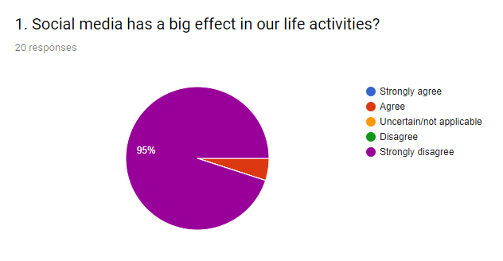
Based on the above findings of first question that show strong result support the big effect on social media on our life activities as it is showing that there are 95% saying that strongly agree.

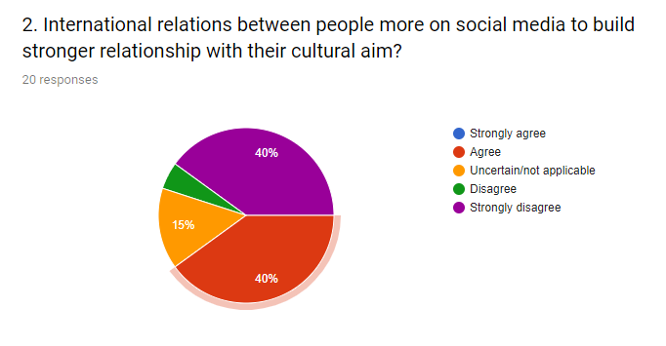result of second question shows this is different ratio rate only 40% strongly agree that social build relationship with cultural aim.
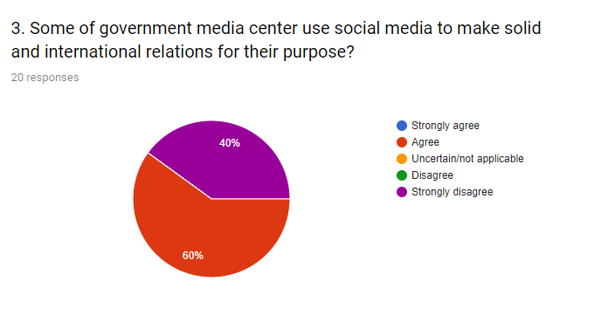
Third question taking consideration regarding the government media center use social media how its impact on people behavior result shows that 60% agree and 40 strongly agree.
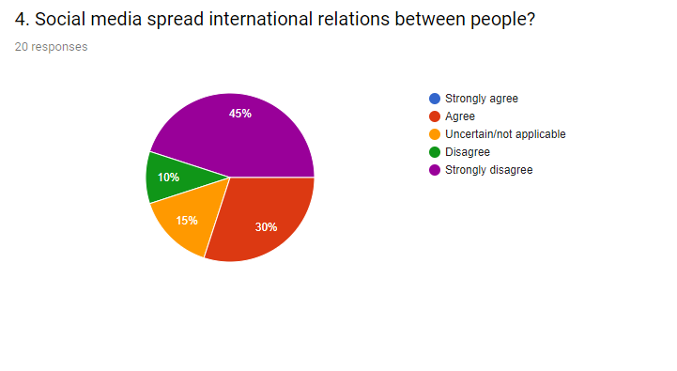
This question asking about the use of social media in international relation practices so result shows that 45% strongly agree where 15% uncertain.

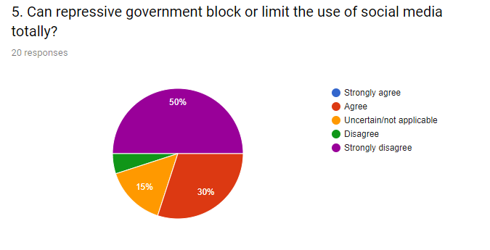

The result of this question shows a big different percentage where 50 % strongly agree and 30 disagrees.

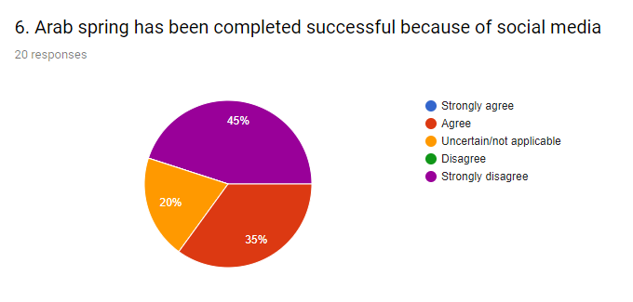

Last question is taking consideration of Arab spring and the social media relation with it result is showing 45% strongly agree as biggest percentage.

4.2 Discussion of the findings:

After the end of the Arab Spring, the Middle East is still active in the use of social media. Major networks are experiencing significant growth in user numbers, and usage trends often reflect the image of users in other regions. This includes the often overlooked power of social media and specially Facebook, the rapid rise of visual social networks and the smaller number of Twitter users than expected.
Understanding the social networks used by the region is important to understand the nature of global businesses, news agencies, NGOs and others who wish to take advantage of this growing market in the region and know the best place to direct their efforts.
At the same time, continued growth in the use of social media, the explosion of smart phones, and the emergence of optical networks focused on videos means that if the events of 2011 will be repeated today, we can expect to see more material coming from social platforms.
Many political regimes in the region see this as creating a level of tension. Turkey, for example, closed social networks in different stages. We have also seen many recent cases in the Gulf region of the arrest of social media users because of their publications on social networks and messaging applications.

4.3 Recommendations:
The main tool which means that The protestors were utilized and harnessed to social mobility during that period, after these revolutions especially if we take the graph of the Tunisian revolution then the Egyptian and then the Libyan explosion For example, in Tunisia, in Egypt, in Libya, from newspapers, private and public radio magazines, and then television networks. This is, of course, the real explosion or the real boom that has taken place in that region for the Internet in general during that period from the first years of 2011.
Perhaps the momentum generated by the revolution was channeled to other channels to the other media and then the street also played an important role because the public squares and public spaces.
If we take the chart, we are witnessing a second or more rise of the role of social networks I mean, for many reasons, the first thing is the state of political and economic blockage, the marginalization experienced by young people, whether in Tunisia, Egypt, Libya, in all these countries that witnessed the spring or the beginning of the Arab Spring. For example, Facebook is now a phenomenal.
The Arab spring protesters were depending and deploy on Internet usage. Moreover, governments were working hard to block many social media access during that time because they aim to decrease protesters activities.
Governments is really relying on technology and advance telecommunication tool such as social media to complete their political goals as example sharing fake news in some regions.

4.4 Summary and Conclusions
Although experts consider the use of the term "Social media revolution" to describe protests in the Arab world as exaggerated, studies have confirmed that social networking on the Internet has played a central role in the Arab Spring.
When hundreds of thousands of people in the Arab world took to the streets in spring 2011 to protest against the ruling regimes, the "Social revolution" quickly began to speak. Social media helped the disgruntled to challenge the ruling regimes and agree to organize demonstrations despite censorship.
Through many conferences on online networks and blogs in many countries of the world studies emphasize the importance of networks such as Facebook and Twitter.
"Social media revolution." This term is considered misleading by researchers. It exaggerates the role of networks, because the great discontent that prevailed last spring has deep causes such as high unemployment and many young people, and the desire for more freedom.

Reference:

Raziq, Abdul. "Syrian Citizen Journalists Risk All to Bring Stories from the Frontlines."PR Watch, the
Aday, S., Farrell, H., Lynch, M., Sides, J., & Freelon,D. (2012). New Media and Conflict After the Arab Spring. Blogs and Bullets II United States Institute of Peace, pages 1-24.

Wilson, C. & Dunn, A. (2011). Digital Media in the Egyptian Revolution: Descriptive Analysis From the Tahrir Data Sets. International Journal of Communication, Vol. 5, pages 1248-1271.

Schattle, H. (2015). Global Media, Mobilization, and Revolution: The Arab Spring. Chapter 5, pages 70-89, in Manfred B. Steger, editor. The Global Studies Reader. New York, New York. Oxford University Press.

Stepanova, E. (2011), The Role of Information Communication Technologies In “The Arab Spring,” PONARS Eurasia Policy Memo No. 159 pages 1-6.

Pew Research Center’s Global Attitudes Project. "Egyptians Embrace Revolt Leaders, Religious Parties and Military As Well; U.S. Wins No Friends, End of Treaty With Israel Sought."April 25, 2012.
Social Media and the Arab Spring: Politics Comes First
https://journals.sagepub.com/doi/pdf/10.1177/1940161212471716

